42.14: a) As a photon,
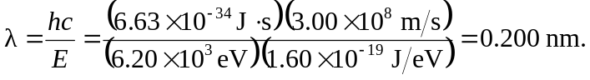
b) As a matter wave,
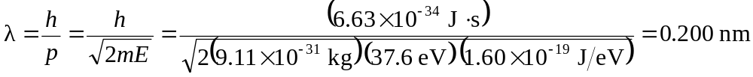and
c) as a matter wave,


